Screenshots:-
1. Home Page
- Description: Displays the welcome message "Welcome to NeurofleetX" with a green traffic light and the subtitle "AI Powered Urban Fleet and Traffic Intelligence". The navigation bar includes links to "Home", "Dashboard", "Login", and "Register".
- Purpose: Serves as the landing page for unauthenticated users.
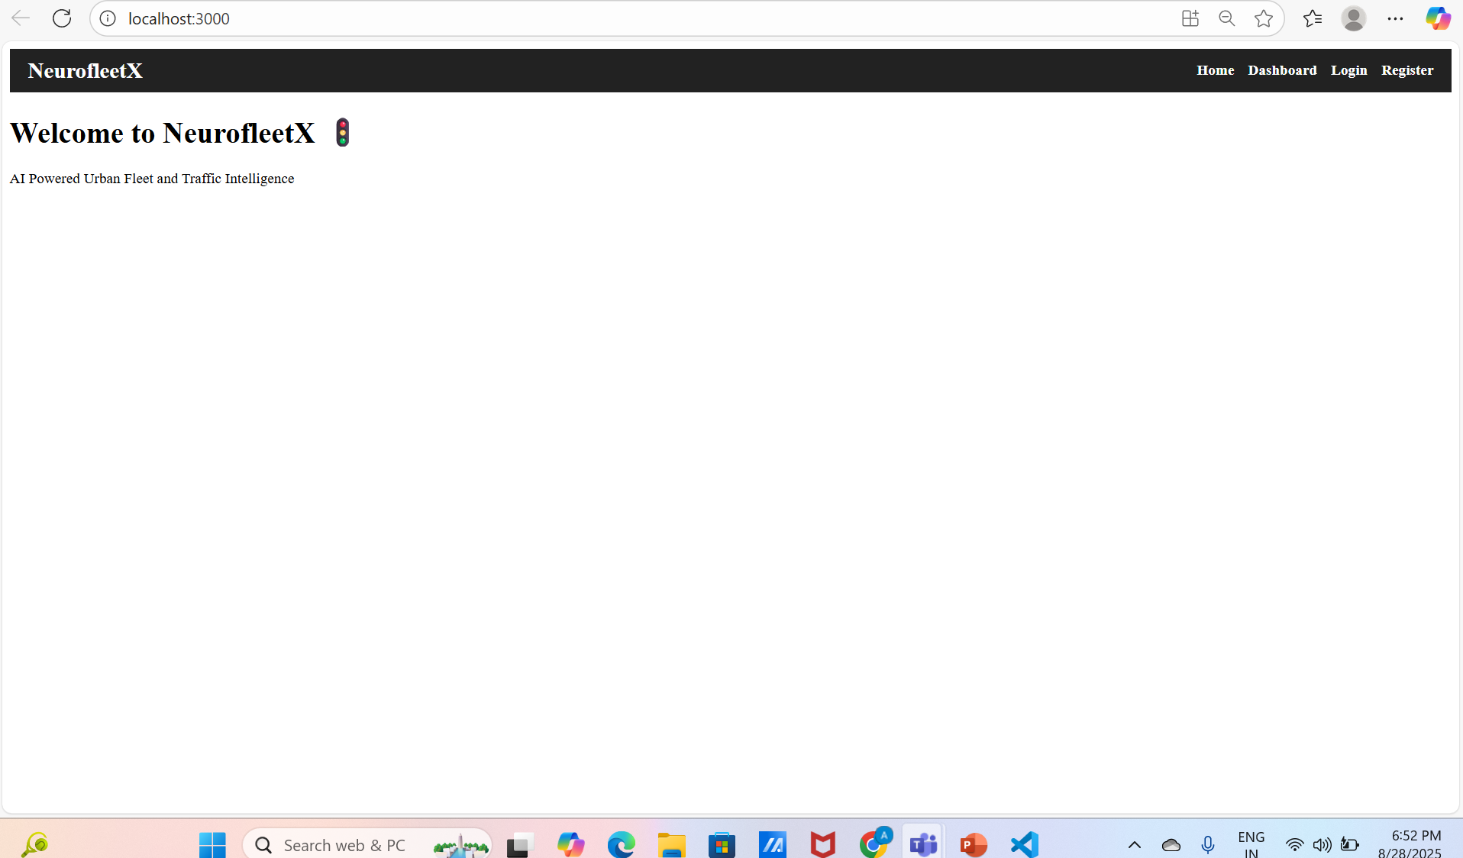
2. Login Page (Normal View)
- Description: Shows the login form with pre-filled email ("anuragtiwari3005@gmail.com"), a password field (masked), and a blue "Login" button. The footer link "Don't have an account? Register here" is visible in purple. Navigation bar is at the top.
- Purpose: Allows users to log in with their credentials.
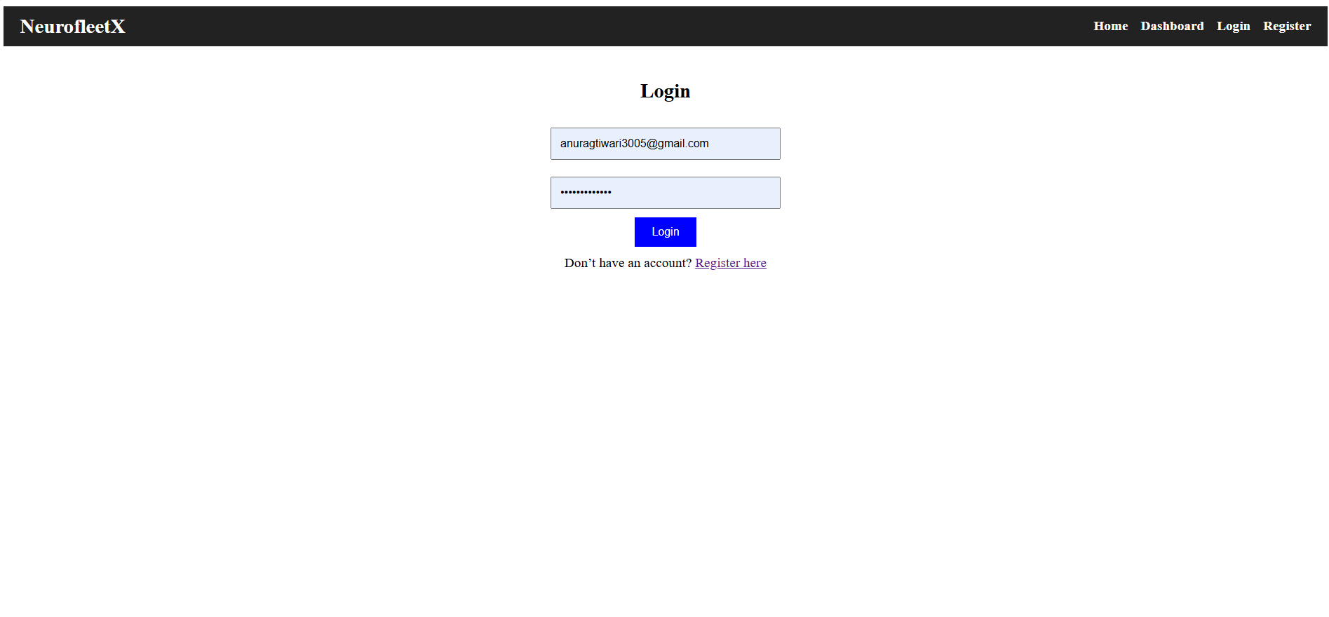

3. Login Page (Validation Error)
- Description: Displays an orange error message "Please include an '@' in the email address. 'anuragtiwari3005ail.com' is missing an '@'" below an invalid email input. The blue "Login" button remains active.
- Purpose: Demonstrates client-side email validation.
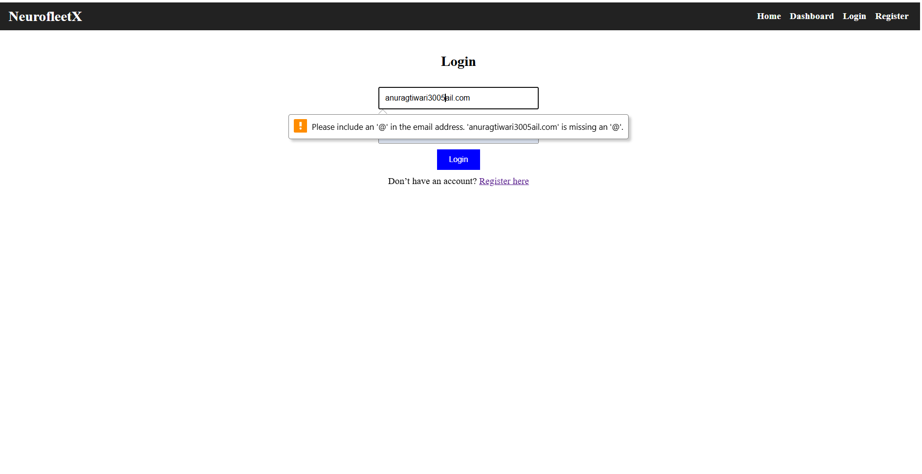

4. Login Page (Success Popup)
- Description: Shows a blue popup toast with the message "localhost:3000 says login successful (dummy for now!)" and an "OK" button after a successful login attempt. The form remains visible in the background.
- Purpose: Confirms dummy login success.
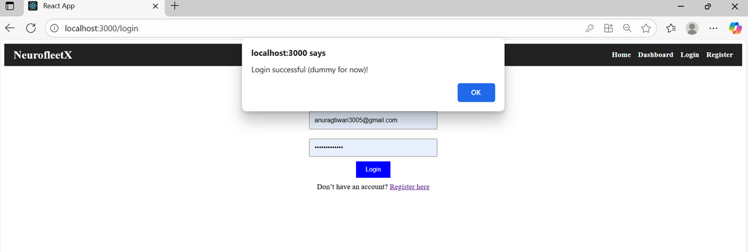
5. Register Page (Normal View)
- Description: Displays the registration form with fields for name ("Anurag Tiwari"), email ("anuragtiwari3005@gmail.com"), password (masked), and a green "Register" button. The footer link "Already have an account? Login here" is in purple.
- Purpose: Allows new user registration.
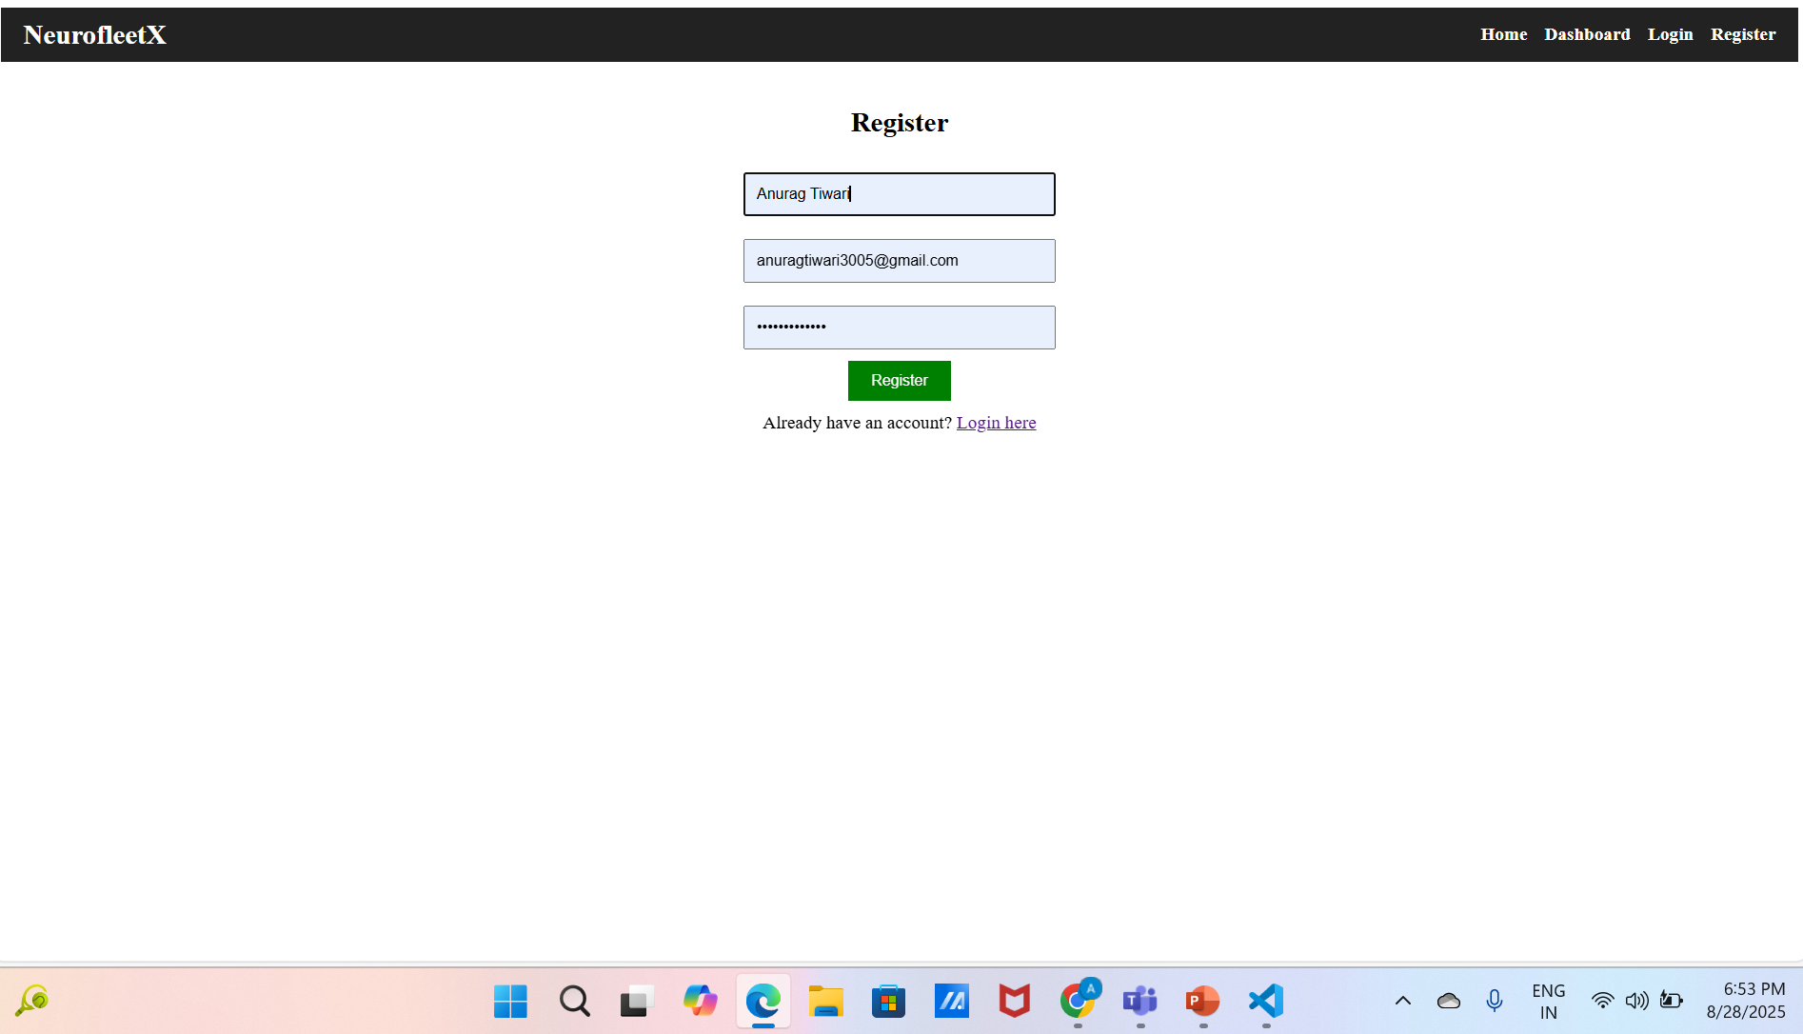
6. Register Page (Success Popup)
- Description: Shows a blue popup toast with the message "localhost:3000 says Registration successful (dummy for now!)" and an "OK" button after a successful registration attempt. The form remains in the background.
- Purpose: Confirms dummy registration success.
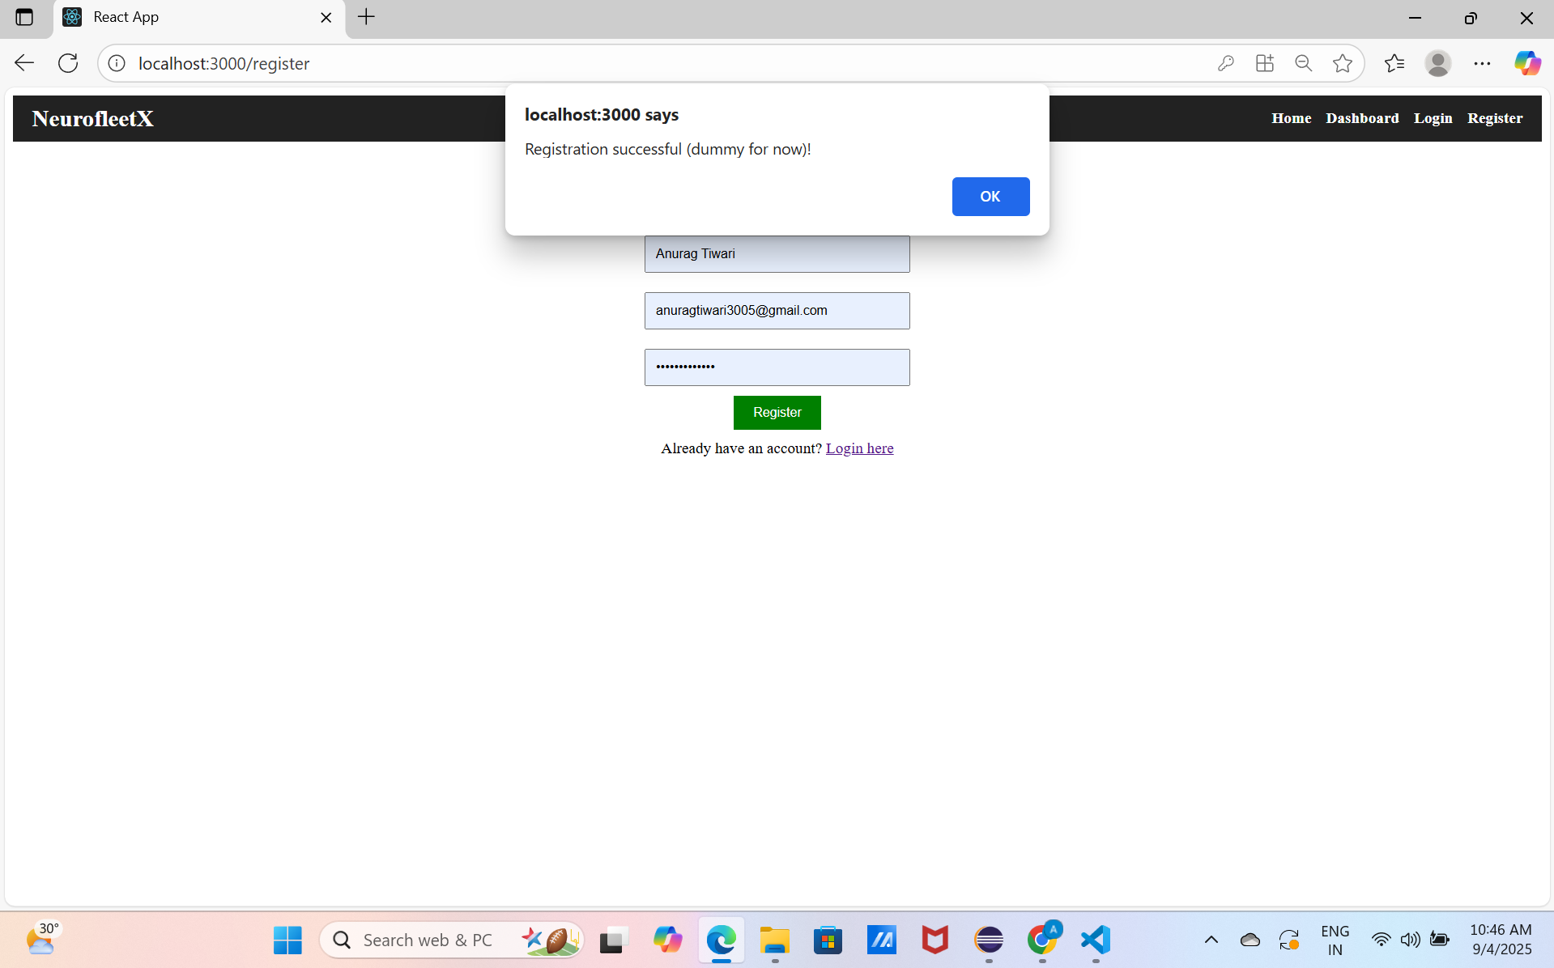

7. Dashboard Page (Unauthenticated)
- Description: Displays the message "You are not logged in " in red with a "Please Login to access the Dashboard" link in purple when accessed without logging in. The navigation bar is present.
- Purpose: Restricts access to authenticated users only.
